Development Log
UFCF9M-30-2 GAME ENGINE programming
PLACEHOLDER:
Read this text before editing etc. Please delete this text as and when appropriate.
As part of your portfolio, you are required to produce a reflective report. This will be used to assess your problem-solving skills as they relate to working with game engine software. You will be given a template structure for this in a separate document via Blackboard at a later date.
To help you reflect on the entire learning journey on the module, we have asked you to complete a development log. Whilst not directly assessed, the log provides evidence for the check-ins and marks will be awarded for regular entries made (the quality of these will not be marked). These should also be included in the Reflective Report as an appendix.
You do not have to use this template document and can choose to produce your development log in whatever form you choose – the template is provided to give an expectation of the information and level of depth we expect to see.
For any further questions, please contact the module teaching team.

Template Entry

Date of Entry

Tasks Completed:
- Task Code: Task Title

Notes & Reflections:
[Your Notes & Reflections Here]

Screenshot/s of Progress:


Example Entry

Mon 21/09/2026

Tasks Completed:
- C1a – Project Forking
- C1b – Game Manager and State Machine
- E1b – Custom Scene

Notes & Reflections:
I completed the core tasks for Worksheet 1 this week. Forking the project was a bit complicated, but creating the game manager and state machine were more straightforward. I chose to modify the game manager using switch statements out of the recommended extensions as I want to develop my coding abilities more. I attempted to make the state machine class-based, but it was challenging and I wasn’t able to complete this, so I’ve commented out the code for the time being and will attempt to complete it again at another time.

Screenshots of Progress:
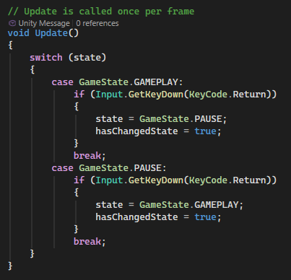

Your Own Stuff
MON 05/10/2026
TASKS COMPLETED
C1a Project Forking
C2b Game Manager & State Machine
E1a Custom Scene
E1b Switch-Based State Machine
Notes: Generally wasn’t too hard I spent some time but managed to get the code working properly
Screenshots:
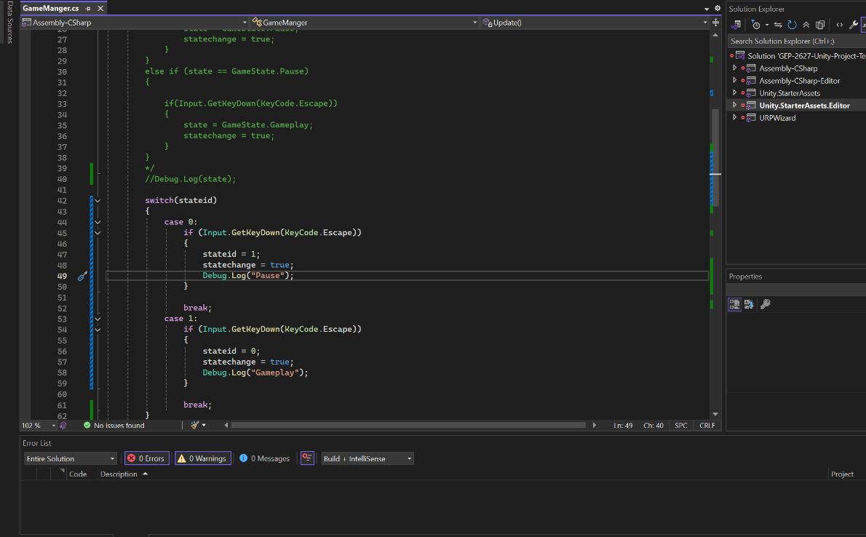

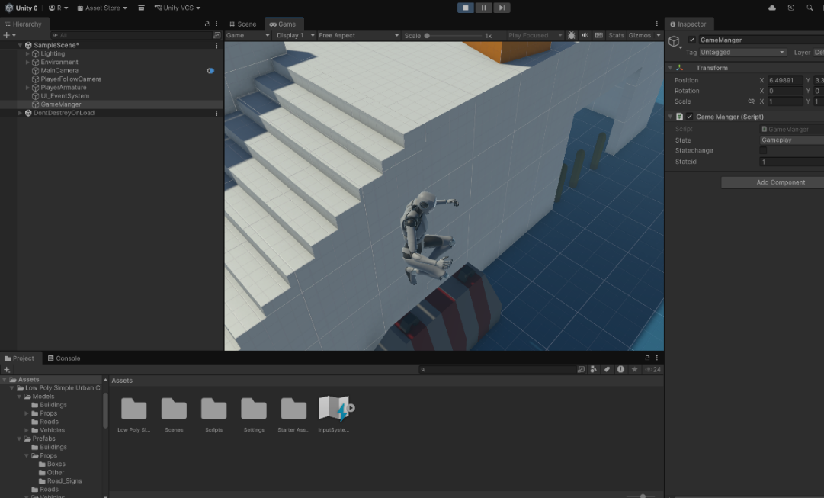
MON 10/12/2026
TASKS COMPLETED
C2a Inventory Class
E2a Inventory Inspector Properties
Screenshots:
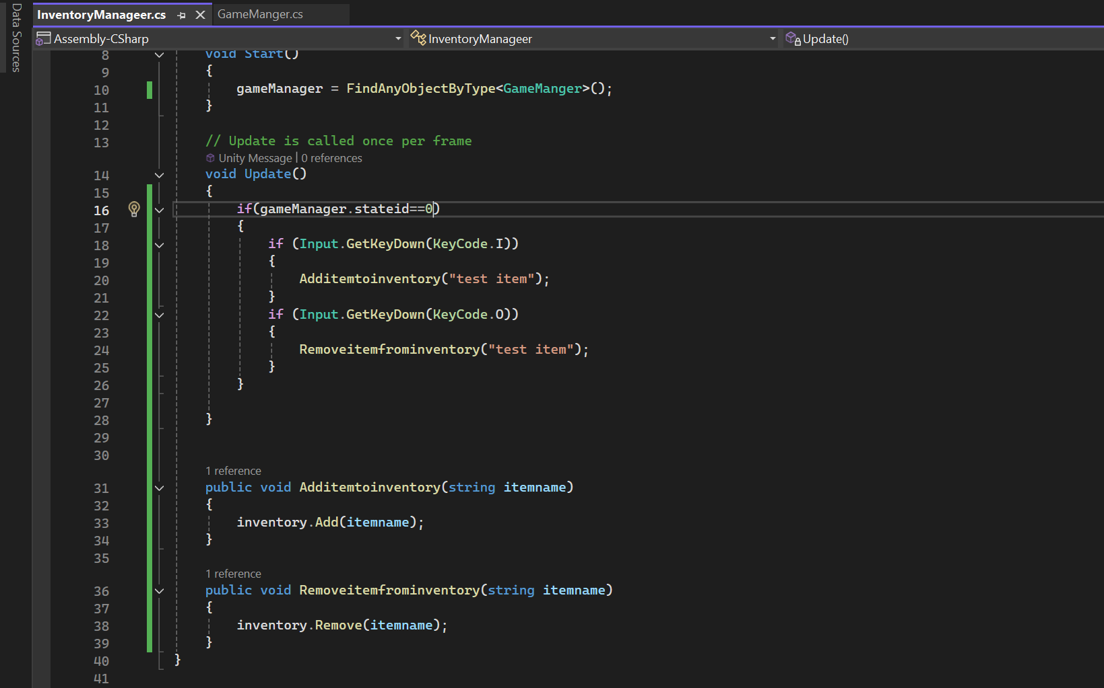

MON 10/19/2026
TASK COMPLETED
C3a Item Class & Object
C3b Adding Items to Inventory
E3a Additional Item Properties
E3b Additional Item Object Components
Note: Added the ball to move towards the player when nearby, Item collecting works with the quantity variable in Items now and will add it to the Inventory multiple times if needed.
Screenshots: